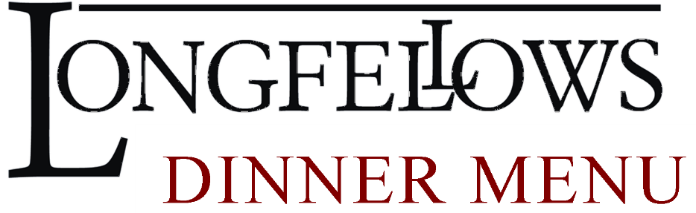
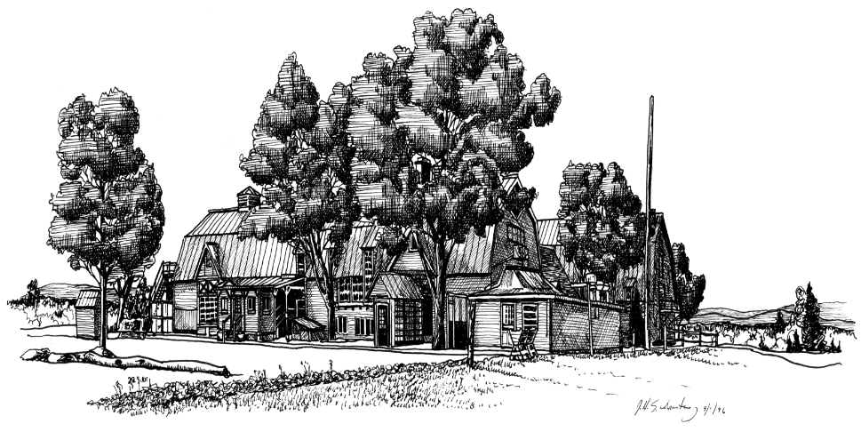
STARTERS
Poutine Carnitas 14
Crisp Fries-Slow Braised Pork-Cheese Curds-Pickled Red Onion & Jalapeno-Cilantro-Chile Gravy
Summer Burrata 15
Fresh Burrata-Heirloom Tomato-Kalamata Olive Streusel-Tomato Gastrique-Grilled Crostini
Mediterranean Beef Kabob 15
Mediterranean Marinated Filet Mignon-Summer Vegetables-Tzatziki Sauce
Shrimp & Grits 15
Four Jumbo Shrimp-Cheddar Grits-Andouille Sausage-Tomato-Scallion-Garlic

SOUPS AND SALADS
French Onion Soup 7
Caramelized Onions-Homemade Beef Broth-Caramelized Provolone and Swiss-Herb Croutons
Soup of the Day 6
Ask your server about todays chef’s creation
Kentucky Bourbon Pecan Salmon Salad 20
Norwegian Salmon-Baby Greens-Pecans-Bleu Cheese-Local Apple-Dried Cranberries-Maple Poppyseed Dressing
Steakhouse Salad 21
Crisp Romaine-Grilled Flank Steak-Heirloom Tomato-Pickled Vegetables
Classic Caesar Salad 6/12
Crisp Romaine-Parmesan & Asiago Cheese-Creamy Caesar-Herb Croutons-Parmesan Chip
Longfellows Garden Salad 6/12
Baby Greens-Tomato-Cucumber-Carrot-Pepper-Herb Croutons-Balsamic Vinaigrette

Upgrade Any Salad By Adding Grilled Chicken 5-Four Jumbo Shrimp 7-Kentucky Bourbon Salmon 8

SANDWICHES
All Sandwiches Served with French Fries and House Made Pickles
Philly Roast Pork 16
Braised Pork-Broccoli Rabe-Provolone-Roasted Garlic Aioli-Cherry Peppers-Ciabatta
Short Rib Grilled Cheese 17
Braised Short Rib-Smoked Gouda-Pickled Red Onion-Arugula-House Made Glaze-Thick White Bread
Farmers Market Vegetable 15
Homemade Hummus-Feta Cheese-Local Summer Vegetables-Ciabatta
Longfellows Burger 16
Ground Brisket and Short Rib-Arugula-Tomato-Red Onion-Slab Bacon-Cabot Cheddar-House Made Pickles
Shrimp Po’ Boy 16
Tempura Fried Shrimp-Shredded Lettuce-Tomato-Remoulade-Hoagie Roll

ENTREES

Harissa Chicken 22
Harissa and Cumin Rubbed Chicken Breast-Potatoes-Leeks- Herb Yogurt-Lemon Cous Cous
Award Winning Cabot Mac and Cheese 20
Cabot Cheese Sauce-Mini Penne-Cabot Cheese and Panko Topping
Add Bourbon Bacon 5-Grilled Chicken 5-Roasted Vegetables 5-Braised Short Rib 6-Braised Pork 6
Shrimp 7-Kentucky Bourbon Salmon 8-Lobster 12
Fish and Chips 21
Beer Battered Haddock-Crisp Fries-Sweet Pickle Tartar-Fresh Coleslaw
Sesame Braised Short Rib 25
Tender Short Rib-Sweet & Spicy Noodles-Pickled Vegetables-Sesame Soy Broth-Cilantro
St Louis Rib Dinner 24
Overnight Roasted Ribs-Creamed Corn Cornbread-Local Bacon & Maple Baked Beans-Fresh Coleslaw
Filet Mignon 30
Eight Ounce Filet Mignon-Au Poivre Sauce-Mashed Potato-Fresh Vegetable
Add Four Jumbo Shrimp 7- Five Ounce Lobster Tail 12
Kentucky Bourbon Salmon 29
Norwegian Salmon-Bourbon Soy Glaze-Wild Rice-Fresh Vegetable
Turkey Dinner 24
Turkey Breast-Sandys’ Sausage Stuffing-Mashed Potato-Fresh Vegetable-Turkey Gravy-Cranberry Sauce
Ricotta & Potato Gnocchi 21
Tender Gnocchi-Arugula-Mushrooms-Onions-Fennel-Tomato-Sage Brown Butter-Balsamic
Add Bourbon Bacon 5-Grilled Chicken 5-Roasted Vegetables 5-Braised Short Rib 6-Braised Pork 6
Shrimp 7-Kentucky Bourbon Salmon 8-Lobster 12
Peruvian Chicken 22
Aji Amarillo Rubbed Thighs and Legs-Coconut Sticky Rice-Tomato Cucumber Salad-Aji Verde

