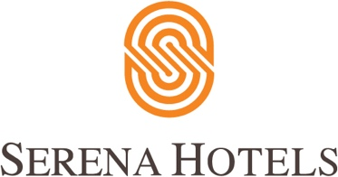

Corporate
10th March, 2022
Islamabad

Networking Lunch with Media Officials

ISLAMABAD: A networking lunch with the senior journalists and bureau chiefs of the top news agencies was hosted in Islamabad, in connection with the 20 years celebrations of Islamabad Serena Hotel.
The senior manager of Marketing at Tourism Services Promotion (TPS) Hussain Odhwani in his opening remarks welcomed the guests. He said the event was only a small token of appreciation for the efforts of the media fraternity, which had helped in promoting tourism & hospitality in Pakistan.
Hussain also discussed the various initiatives that Serena Hotels has undertaken in the past 20 years in order to promote the culture, tradition, talent and the heritage of Pakistan.
These ventures include Adventure Diplomacy to promote different expeditions in Pakistan and abroad, such as mountaineering and skiing. A Public Diplomacy initiative to promote dialogue on critical issues, Cultural Diplomacy to revive and reconnect with the art of poetry, music, and literature, and lastly, a Sports Diplomacy initiative to discover the athletic potential in Pakistan.
He announced the company’s support for an upcoming river rafting expedition along the course of the Indus, by Wajahat Malik and his team. Falling under the Hotel’s Adventure Diplomacy banner, this would be first of its kind in the history of Pakistan.
He highlighted the Hotel's endeavours towards the economic development of underrepresented communities, especially in Gilgit-Baltistan, through development and support initiatives.

