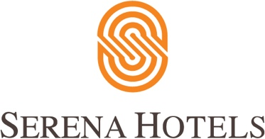

Corporate
8th March, 2022
Islamabad

Women’s Day Networking Breakfast to Honour Talented Women

ISLAMABAD: Serena Hotels hosted a Networking Breakfast on Tuesday to celebrate International Women’s Day and honour, recognise and applaud the talented women. This year the Women’s Day celebration was also part of the Islamabad Serena Hotel’s 20 year anniversary celebrations.
Women from all walks of life including the guests, associates, entrepreneurs, and representatives of the civil society along with a large number of diplomats and their spouses joined the celebrations. Samina Alvi, the First Lady, was the chief guest.
On this occasion, various stalls featuring Pakistani handicrafts and traditional items, made by differently abled children, women artisans in underprivileged homes and other arts and crafts were displayed by women organisation represented by Indus Heritage, Andaaz, Mashal Association, Air Organics, Behbud Crafts, Care for Special Children Organisation, Pakistan Navy Women Association, Pakistan Foreign Office Women’s Association, the Aga Khan Economic Planning Board, and Chann Mahi Handicrafts.
The First Lady also visited various stalls and evinced interest in items displayed there. She also praised the work of artisans. The guests thoroughly enjoyed live music and an entertaining trivia session in a well decorated Sheesh Mahal.

