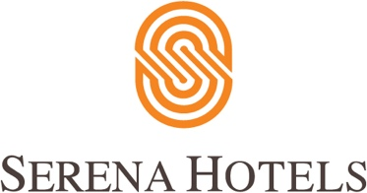

Corporate
5^{h} March, 2022
Islamabad

Crafts Exhibition held at Serena Hotel

ISLAMABAD: Handmade jewellery, block printed items and other handicrafts have been put on sale at a two-day festival, held to promote traditional crafts of Pakistan.

The objective of organising this festival was also to showcase the talent of local women so they could feel empowered, one of the organisers of the event said.

Celebrating 20 years of presence in the capital city, the festival has been organised by the management of Serena Hotels in collaboration with Nomad Gallery.

A significant number of citizens visited different stalls throughout the day. Pillow covers, items decorated with truck art, crockery and a variety of organic dry fruit and honey was also being sold.

Announced open by Maleeha Lodhi, who was Pakistan’s former representative to the United Nations, the festival is one of the events being organised by Serena Hotels to celebrate its 20th anniversary.
A guest said that she had visited similar events at the hotel before and it was where she preferred to purchase honey and sometimes dry fruit.
Apart from food items, another guest, also a regular to similar joint events held in the past particularly came for the truck art items. The two-day event continued for two days.

