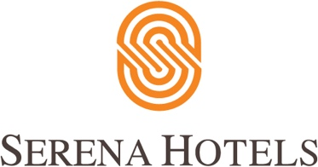

19th December 2021
Serena Corporate

21st Asian Individual Squash Championship 2021

21st Asian Individual Squash Championship for Men & Women organized by Pakistan Squash Federation (PSF) concluded today at Mushaf Squash Complex, Islamabad. The Men’s event comprised 32 players, whereas the Women’s event had a 16 players’ draw. Apart from Pakistan, a group of international players, officials and referees from Hong Kong, Iran, Kuwait, Malaysia, Qatar, Singapore & Sri Lanka participated in the tournament.

The Finals of Men & Women events were played today. Air Marshal Aamir Masood, Senior Vice President PSF, graced the closing ceremony as Chief Guest and awarded trophies & prize money amongst the finalists. Squash legends Mr Qamar Zaman and Mr Jansher Khan along with event sponsors also attended the prize distribution ceremony.

The Women’s Final was played between Tong Tsz Wing from Hong Kong and Rachel Mae Arnold from Malaysia wherein Tong Tsz Wing defeated Rachel Mae Arnold with a game score of 3-0 (11-8,13-11 and 11-5) in 34 minutes. The Men’s Final was played between Ng Eain Yow from Malaysia and Yip Tsz Fung from Hong Kong in which Ng Eain Yow clinched the Men’s title of 21st Asian Squash Championship. He defeated Yip Tsz Fung with a game score of 3-0 (11- 6, 13-11 and 11-9) in 40 minutes and won the championship finals.

Successful hosting of the mega event is reflective of Pakistan’s commitment to promotion of sports both in country and at international level.

