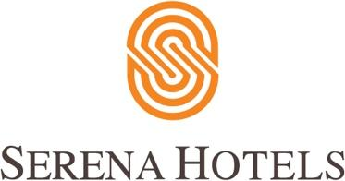

Corporate
Islamabad, February 12, 2020

Serena Hotels sponsored a fundraising event for DIL Foundation

In an effort to raise funds to provide a quality education for underprivileged children, Serena Hotels organised a fundraiser in collaboration with Developments in Literacy (DIL) for children living in remote areas of Pakistan.

The fundraiser included a musical evening at Islamabad Serena Hotel on 15th February 2020. DIL is a not-for-profit NGO established in 1997 and is celebrating its 20th anniversary this year.

The initiative has opened up a world of opportunity for 25,557 students (64% of whom are girls) at 134 campuses across Pakistan by developing an institution which inspires a love of learning and teaches the students skills necessary to live a stable life.

ABOUT SERENA HOTELS
Serena Hotels has established itself as one of the world’s leading hospitality brands offering quality accommodation, unique holiday and conference solutions, cultural heritage and adventure tourism. Its collection of 35 unique hotels, resorts, safari lodges and camps, palaces and forts located in East Africa (Kenya, Tanzania, Zanzibar, Rwanda and Uganda), Mozambique and South Asia (Pakistan, Afghanistan and Tajikistan) are in some of the world’s most interesting, enchanting, historic and exotic settings.

Press Contact
Hussain Odhwani
Senior Manager Marketing & Communication
Tel: +92 333 6349264
hussain.odhwani@serena.com.pk

