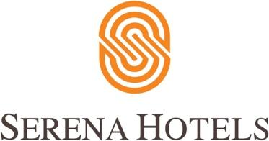

Corporate
Islamabad, February 12, 2020

Diplomats’ spouses launch cookbook

The Heads of Diplomatic Mission’s Spouses Group launched Culinary Diplomacy: Sharing Recipes, Building Bridgesin collaboration with Serena Hotels.

Samina Arif Alvi was invited to the event as chief guest.The spouses of some 50 foreign envoys in Islamabad launched the cookbook, which uses 144 recipes from 50 countries across six continents to introduce culture through cuisine.

Ghada Ahmed, the spouse of the Egyptian ambassador, said: “This marks the culmination of my tenure of two years as President of the Spouses’ Group since March 2018 and also the end of mine and husband’s term in Pakistan, so this is my farewell to you all. The book that we are launching today is the jewel of the crown of our activities over the past two years.”

She added: “This project aims to promote our cultures among the Pakistani people by introducing our cuisines and the stories that lie behind the dishes we prepare every day. It also aims to generate revenues by the sale of the book that will all go to a charity organisation in Pakistan to improve the wellbeing of Pakistani individuals and give them better chances in life.”

Ms Alvi, who also wrote the foreword of the book, said: “It is an honour for me to take the responsibility to commit the proceeds from the sale of the book to a charitable cause. I am pleased to say that I will be committing the proceeds to Ehsaas, the government’s poverty alleviation programme to promote vocational training of the disabled.” Five books signed by Ms Alvi were auctioned during the event.

ABOUT SERENA HOTELS
Serena Hotels has established itself as one of the world’s leading hospitality brands offering quality accommodation, unique holiday and conference solutions, cultural heritage and adventure tourism. Its collection of 35 unique hotels, resorts, safari lodges and camps, palaces and forts located in East Africa (Kenya, Tanzania, Zanzibar, Rwanda and Uganda), Mozambique and South Asia (Pakistan, Afghanistan and Tajikistan) are in some of the world’s most interesting, enchanting, historic and exotic settings.

Press Contact
Hussain Odhwani
Senior Manager Marketing & Communication
Tel: +92 333 6349264
hussain.odhwani@serena.com.pk

