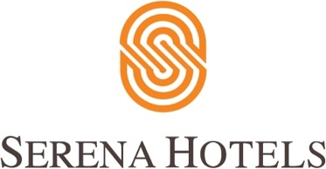

HBL, Serena Extendes it’s Meals Offering to Frontliners

ISLAMABAD, 8th June 2020 – Habib Bank Limited (HBL) and Serena Hotels have pledged to continue providing high-quality meals to frontline medical professionals in the COVID-19 designated hospitals in seven cities where Serena Hotels are located.

HBL and Serena had launched the joint initiative “Jazba e Khidmat” in early April to pay tribute to the medical professionals including doctors, paramedics and nurses actively playing a role in battling the COVID-19 pandemic. The meal boxes are delivered daily for lunch and dinner to almost 20 hospitals and health camps in the cities of Islamabad, Rawalpindi, Faisalabad, Swat, Quetta, Gilgit and Khaplu. The extension of the initiative, which was decided upon in light of the continuation of the COVID-19 crisis, will lead to 80,000 meal boxes being delivered as a goodwill gesture to the frontliners till end of June.

The idea behind Jazba-e-Khidmat is to recognize and salute the services of medical staff who are battling to keep the society safe during the pandemic by serving them quality nutritious meal. Federal Health Minister Zafar Mirza, while announcing the initiative in April, stated that the Ministry appreciated “this admirable thought by Serena Hotels and HBL for the medical workers”.

Being Pakistan’s largest bank and leading hotel chain respectively, HBL and Serena Hotels are playing their role as responsible corporate citizens, and have undertaken a range of positive initiatives in light of COVID-19 pandemic to support the Government and society.

