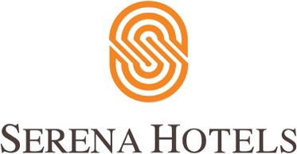

HBL, Serena Provide over 85,000 Complimentary Meals To Covid-19 Frontliners

ISLAMABAD, 29th July 2020 – Habib Bank Limited (HBL) and Serena Hotels have successfully concluded their almost 4 month-long joint initiative “Jazba-e-Khidmat” for delivering high-quality meals to frontline medical professionals in the COVID-19 designated hospitals in the cities where Serena Hotels are located.

HBL and Serena had launched the joint initiative “Jazba e Khidmat” in early April to pay tribute to the medical professionals including doctors, paramedics and nurses who have been serving at the frontline during the COVID-19 pandemic. The meal boxes have been delivered daily for lunch and dinner to more than 27 hospitals and health camps in the cities of Islamabad, Rawalpindi, Faisalabad, Swat, Quetta, Gilgit and Khaplu. At the conclusion of the initiative over 85,000 meal boxes have been delivered as a goodwill gesture to the medical frontliners until 30th July 2020.

CEO Serena Hotels Aziz Boolani thanked HBL for joining hands with Serena Hotels in this initiative, and also lauded the medical professionals for their unwavering duty in saving lives of the people during the pandemic. Furthermore, he thanked the Serena kitchen teams all over to the country and applauded their commitment of preparing the meals daily throughout the peak period of the Covid-19 crisis.

The idea behind Jazba-e-Khidmat was to recognize and salute the services of medical staff who are battling to keep the society safe during the pandemic by serving them quality nutritious meals. Federal Health Minister Zafar Mirza had announced the initiative in April and appreciated “the admirable thought by Serena Hotels and HBL for the medical workers”.

Being Pakistan’s largest bank and leading hotel chain respectively, HBL and Serena Hotels are playing their role as responsible corporate citizens, and have undertaken a range of positive initiatives in light of COVID-19 pandemic to support the Government and society.

