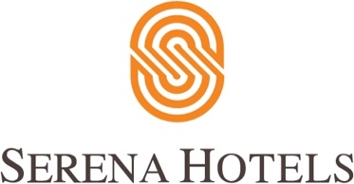

HBL, Serena pledge 30,000 meals for frontline medics

HBL and Serena Hotels have joined hands to provides 30,000 mealboxes over a period of one monthin seven cities to medical professionals battling at the frontline of coronavirus pandemic. The collaboration, ‘Jazba-e-Khidmat’, is a joint initiative of HBL and Serena Hotels and aims to provide specially prepared mealboxes to the medical teams at the COVID-19 designated hospitals and health camps in seven cities: Islamabad, Rawalpindi, Faisalabad, Swat, Quetta, Gilgit and Khaplu. The mealboxes will be provided twice a day to all the medical team members in 20 hospitals countrywide for a month. Medical professionals are doing a tremendous service to society by battling on the frontlines against the Coronavirus pandemic. Efforts should be undertaken to ensure the health and safety of these medical professionals. Only then will they be able to save the society from this pandemic, a press release issue dby Serena Hotels said. “HBL, Pakistan’s largest bank and a responsible corporate citizen, is keenly aware of its duty to support Pakistan at this difficult time. The Bank enjoys presence in all those cities where Serena Hotels have presence in. The Bank’s role in financing these mealboxes is part of its larger effort to assist the society combat coronavirus. Serena Hotels, Pakistan’s leading Hotel chain, will provide quality mealboxes with nutritious food to keep the medical professionals energized,” it concluded.

