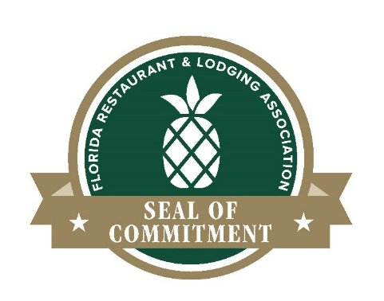
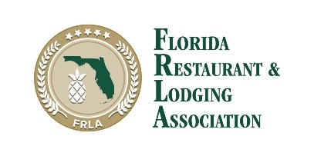

Riverside Hotel Achieves Top Sanitation and Safety Award from the Florida Restaurant and Lodging Association
Fort Lauderdale, Florida – On July 24, 2020, the Riverside Hotel was awarded the Florida Restaurant & Lodging Association (FRLA) Seal of Commitment – a promise that our establishment achieved enhanced safety and sanitation standards as designated by FRLA to ensure the safety of guests and employees. In a post COVID-19 atmosphere, our goal is that guests have confidence that our business is sanitary and safe, and staff are well trained when they see an FRLA Seal of Commitment on the door.
“What an honor to receive this type of recognition by the Florida Restaurant & Lodging Association. Over the past several months our team went above and beyond the call of duty to ensure new cleaning and sanitation standards were developed and implemented. We further kept aligning us with the latest CDC guidelines to ensure that all our guests, patrons, vendors and team members would be able to enjoy a safe environment at the Riverside Hotel. We even implemented new technology such as thermal cameras, UV light disinfecting wands and Ionizing HVAC air purification systems, “said Heiko Dobrikow, EVP & GM of the Las Olas Company & Riverside Hotel.
“FRLA is proud to designate Riverside Hotel with our Seal of Commitment for their commitment to sanitation excellence,” said Carol Dover, President and CEO of the Florida Restaurant and Lodging Association. Through this achievement, they are demonstrating their serious pledge to ensure the safety and health of their employees and guests, and we commend them.”
For Riverside Hotel to earn the Seal of Commitment, we have dedicated time and invested resources to ensure our establishment, staff, and guests remain safe and healthy while patronizing our business. Our establishment has completed management, food safety, and COVID-19 safety and sanitation trainings. We have also developed and maintained standard operating procedures with intensive safety and sanitation standards.
Restaurants and hotels can learn more about the FRLA Seal of Commitment and apply for certification online: www.frla.org/SealOfCommitment.
Learn more about our establishment’s safety and sanitation guidelines here: https://bit.ly/RiversideHotelSafeStay.

About The Riverside Hotel
The Riverside Hotel is located in the heart of Downtown Fort Lauderdale with its doorstep on the city’s prestigious Las Olas Boulevard. Opened in 1936 by the Wells family, who also developed the Boulevard, the Riverside Hotel is both luxurious and laidback, mixing Caribbean style with old Florida charm. The 12-story property features 231 guestrooms inclusive of 6 suites with jaw-dropping views overlooking the city skyline and New River. Amenities include a heated outdoor swimming pool; a fitness room; complimentary wireless internet; a marina with boat dockage space; more than 11,000 sq. ft. of indoor banquet/meeting facilities; and outdoor catering venues ranging from 800 sq. ft. – 20,600 sq. ft. The hotel also houses several dining options including the award winning Wild Sea Oyster Bar and Grille, Preston’s Wine & Martini Lounge, the Golden Lyon Vintage Pub, and the waterfront Boathouse at the Riverside. The Riverside Hotel is located at 620 East Las Olas Boulevard in Ft. Lauderdale, FL, just minutes from the Fort Lauderdale International Airport, Port Everglades and the sandy white beaches of Fort Lauderdale. For additional information and booking please visit www.RiversideHotel.com.
For additional information on the Press Release, please contact:
Carol Tracz, Director of Sales & Marketing
Riverside Hotel, 620 East Las Olas Boulevard, Fort Lauderdale Florida
ctracz@riversidehotel.com or 954-467-0001
###

